The Role of IL-18 in Abdominal Aortic Aneurysm Formation
Buddhila Wickramasinghe
Student ID: 19208625
Team 5

Key words: Inflammasomes, macrophages, aorta
Word count: 1968

Key-points summary

- Aortic abdominal aneurysms are believed to be formed due to the function of a specific immune cell called macrophages upon being activated by a cell signalling pathway.
- Stimulated macrophages travel to the aortic vessel wall and secrete substances that weaken the structure of it. Weakened blood vessels could rupture due to the pressure of the blood travelling through them.
- Previous studies have recognized that blocking a certain receptor molecule of the cell signalling pathway called inflammasome and another downstream molecule inhibits the formation of aneurysms in mouse models. The mechanisms of how this blocking prevents aneurysm formation is unknown.
- Therefore, this study investigates how the blocking of that downstream molecule may contribute to the inhibition of aneurysm formation. If successfully clarified, pharmacological interventions can be designed to inhibit the molecule and therefore, treat abdominal aortic aneurysms.
- The current study could not establish how the molecule contributes to the formation of aneurysms.

Abstract
A permanent ballooning of the aorta is defined as an aortic aneurysm. Abdominal aortic aneurysms are the most prevalent form of aortic aneurysms among the population. Since surgical repair is the only available treatment option, there is a serious need for less invasive medications. However, as it is not fully understood, more research needs to be dedicated to investigating the pathogenesis behind the condition. As macrophage infiltration and inflammation are believed to be involved with aneurysmal formation, this study aimed to look at IL-18 that is believed to stimulate the recruitment of macrophages. We used a set of IL-18 knock out mice and wild type mice, infused them with angiotensin II to induce aneurysm formation in them and performed immunofluorescence to look at their aortic cross sections. Findings suggest that IL-18 inhibits the formation of aneurysms although if this is caused due to a reduction in macrophages resulted by the knocking out of IL-18 is not clear. Further studies need to be conducted avoiding the limitations of the current study to establish the role of IL-18 in abdominal aortic aneurysm formation.

Introduction
Abdominal aortic aneurysms (AAA) are defined as the permanent dilation of aortic vessel wall that occurs predominantly in the infrarenal region (1, 2). Although the condition is asymptomatic, rupture of the progressively dilated vessels could be fatal (1-4). AAA remains a pathological condition with surgical repair as the only available treatment option. As surgery is associated with significant complications, extended recovery periods and reduced durability, there is a serious need for pharmaceutical treatments to prevent aneurysmal growth and rupture (1-3). Recent rodent studies have proposed smoking cessation, exercise, beta blockers, statins, angiotensin pathway inhibition and doxycycline as potential medical treatments (1). However, further studies are required to measure the efficacy of these interventions
Although molecular mechanisms of AAA formation are not well elucidated, known details suggest that it is closely associated with macrophage infiltration and subsequent inflammation, disruption of vascular smooth muscle cell plasticity and destructive breakdown of extracellular matrix (ECM) due to the production and activation of various cytokines and proteases such as matrix metalloproteinases (MMP) (1, 2, 4-7). In AAA formation, activated inflammatory cells such as macrophages are thought to infiltrate the aortic tissue and drive the secretion of MMPs to promote the destruction of ECM (8). Macrophages can be activated via multimeric intracellular receptor molecules known as inflammasomes. Reportedly, inflammasomes process the activation of various pro-inflammatory cytokines and regulate inflammation in other chronic disease conditions (9, 10). Furthermore, out of several phenotypes, NOD-like receptor family pyrin domain-containing protein 3 (NLRP3) inflammasomes are mainly thought to contribute to the pathogenesis of AAA (9). Inhibition of NLRP3 inflammasomes evidently decreases hypertension and renal inflammation as well as aneurysm rupture (10, 11). Oligomerization of NLRP3 inflammasomes stimulated by several pathogen- and danger- associated molecular signals such as lipopolysaccharides (12), reactive oxygen species, microcrystals and high concentrations of salt, leads the conversion of pro-caspase-1 into active caspase-1 (9-11). Consequently, caspase-1 proteolytically cleaves pro-interleukin (IL)-18 into the active proinflammatory cytokine, IL-18 (10-12) which then leaves the native cells and promotes inflammation and ECM degradation of VSMCs by recruiting macrophages to the aortic vessel wall (10, 11). As IL-18 is linked with several disease states including atherosclerosis and is a vital marker of cardiovascular death and supposedly drive macrophage infiltration (5), its contribution towards AAA pathogenesis is worth investigating. Moreover, findings of a previous in vivo study suggest a higher prevalence of AAA development is associated with elevated IL-18 levels and deficiency of IL-18 significantly attenuates macrophage infiltration in abdominal aortas. Therefore, inhibition the NLRP3 inflammasome activation and its downstream IL-18 could be potential pharmacological targets for the disease. However, further studies should be dedicated to understanding the mechanisms of action of inflammasomes and IL-18 more thoroughly in favour of developing medical treatments based on their inhibition.
In this study, we hypothesise that IL-18 promotes macrophage infiltration which in turn promotes the formation of abdominal aortic aneurysms and therefore, genetic ablation of IL-18 reduces macrophage migration to the aortic vessel wall. Through this study, we aim to determine how IL-18 deficiency affects macrophage infiltration in abdominal aortic aneurysms using IL-18 knock out mouse models.

Methods

Animal and Ethics approval
Male C57BI6 wild type (WT) and male IL-18 knock out (IL-18^{-/-}) mice aged 8-10 weeks old were obtained from La Trobe Animal Research Training Facility (Bundoora, Australia). The study was approved by the La Trobe Animal Ethics Committee (AEC 16-93).

Induction of AAA
Under inhaled isoflurane anaesthesia, WT (n=8) and IL-18^{-/-} (n=4) mice were implanted with a subcutaneous osmotic minipump containing Angiotensin II (Ang II) and were infused with Ang II (1.44 mg/kg/day) over period of 28 days to induce hypertension and therefore, make them prone to developing AAA. Following the treatment period, all twelve mice were closely examined for eight days. Their blood pressure was measured using a tail cuff. All mice were in individually ventilated chambers with free access to regular chow and water during that period.

Immunofluorescence staining
At the end of the in vivo treatment period, all WT and I IL-18^{-/-} mice were killed through CO₂ asphyxiation. Their abdominal aortas were freshly harvested and snap frozen in Tissue-Tek® O.C.T (Sakura Finetek, Japan) overnight at 4ºC. Cryosections of isolated aortas were cut into 5 μm sections using Leica cryostat and were placed on slides. One slide contained approximately 2-3 cross sections from the same mouse model. Cells in WT and IL-18^{-/-} tissue sample were fixed using acetone to prevent protein degradation before proceeding with the rest of the experiment. Upon being washed multiple times with PBS, BSA was added to all tissue samples to prevent unspecific binding. The primary antibody, rat anti-F4/80 was diluted 1:500 into PBS and was then added to bind macrophages. Tissue samples were incubated overnight at 4ºC. The following day, after washing with PBS multiple times, the secondary antibody, Alexa Fluor 555-conjugated goat anti-rat IgG was diluted 1:250, added to the samples and left for two hours at room temperature for 3 hours.
A primary negative control was included whereby primary antibodies were omitted and only the secondary antibodies were incubated with the specimen. This was in order to ensure that there is no non-specific binding of the secondary antibody.
Slides were then treated with fluorescence mounting medium and DAPI (Vectashield anti-fade mounting medium), sealed with acetone and visualized under 20-40X magnification using Olympus BX-8 epifluorescent microscope through an Olympus BX-73 inflorescent microscope with a DP-10 camera attached.

Determining the degree of macrophage infiltration
ImageJ Fiji software was used to quantitatively determine the degree of macrophage infiltration through F4/80 stain. Relative fluorescence as a percentage of the total cross-sectional area of the aortic cross sections was calculated.

Statistical Analysis
Graph Pad Prism was used to analyse the acquired data. An unpaired T test was conducted to carry out a comparative analysis between test and control groups. P < 0.05 was considered to be statistically significant.

Results

IL-18KO did not develop Ang II-induced AAA
No development in AAA was observed in any of the IL-18^{-/-} mouse models upon being infused with Ang-II over a period of 28 days. Furthermore, 50% of WT mice who were treated with Ang-II developed AAA whereas the rest of the 50% had no acquired AAA.

Macrophage infiltration is decreased in IL-18^{-/-} mice
Macrophage infiltration in IL-18^{-/-} mice (Figure 1B) was detected to be lower compared to the WT mice. Although this decrease was not statistically significant (p = 0.09), there was a trend towards reduction in macrophage infiltration in IL-18^{-/-} mice (Figure 2A). Specifically, WT mice with no AAA (Figure 1A) and IL-18^{-/-} mice approximately depicted a similar degree of macrophage infiltration (Figure 2B). On the other hand, when the IL-18^{-/-} mice are unaccounted for, the level of macrophage infiltration in WT AAA mice (Figure 1C) was strikingly higher than that of WT mice with no developed AAA with a statistical significance (p < 0.0001) (Figure 2C).

Figures
Figure 1. Representation of macrophage infiltration in blood vessel adventitia of each type of mouse model cross sections. Immunofluorescence staining of the aortic cross sections of Ang II treated (A) WT mice with no developed AAA (B) IL-18 KO mice and (C) WT who developed AAA. Green embodies the auto-fluorescent elastin layer in vessel walls whereas orange represents the macrophages that have infiltrated the vessel walls.

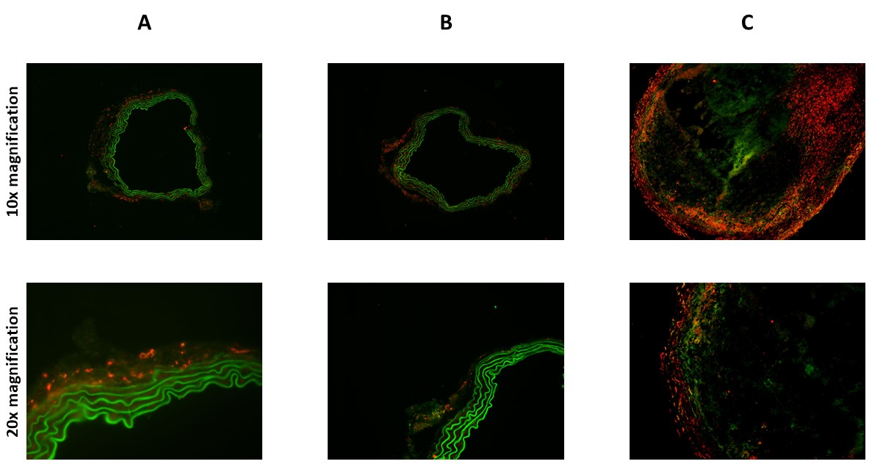
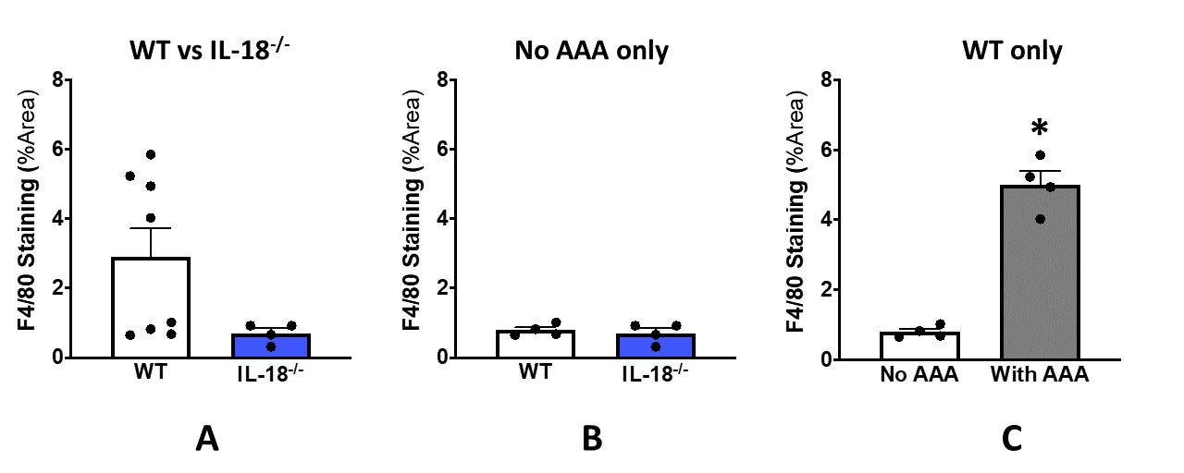
NS
P=0.09
Figure 2. Comparisons of the degree of macrophage infiltration between the aortic cross sections of different types of test groups. These data demonstrate the mean percentage area of F4/80 stain (macrophage infiltration) in aortic cross sections of (A) WT (n=8) verses IL-18^{-/-} mice (n=4), (B) WT mice with no AAA (n=4) verses IL-18^{-/-} mice (n=4) and (C) WT mice with no AAA (n=4) verses WT mice with developed AAA (n=4). These data are presented as mean ± SEM. *Significant difference, p < 0.0001

NS
P=0.09

Discussion
This study mainly demonstrated that (1) Ang-II infusion leads to no development of AAA in IL-18^{-/-} mice where WT mice has a 50% chance of successfully developing AAA under the same conditions and (2) that there is no significant difference in macrophage infiltration between aortic cross sections of IL-18^{-/-} and WT mice with no AAA when WT AAA mice are not accounted for.
Literature proposes that activated IL-18 promotes the recruitment of macrophages to the aortic vessel wall and these macrophages play a role in the development of AAA through directing the inflammation and ECM degradation of VSMCs in blood vessel walls (10, 11). Thus, the current study sought to determine whether knocking out IL-18 reduces the degree to which the vessel wall adventitia gets infiltrated by macrophages under aneurysmal settings. Furthermore, the study was conducted under the hypothesis that if there is a reduction, it is caused due to the absence of IL-18. Results of the study confirms that IL-18^{-/-} mice are protected against AAA. Consistent with literature (2), the current study further demonstrates that macrophage infiltration in aortic vessel wall is indeed accelerated during the development of AAA as depicted through the comparison of the level of macrophage infiltration between WT mice with AAA and WT mice with no AAA. Therefore, to determine whether IL-18 mediates the migration of macrophages in AAA, it is not feasible to compare the statistics of IL-18^{-/-} mice with WT mice who have aneurysms, as the absence of AAA in IL-18^{-/-} mice anyway suggests a low level of macrophage migration into the vessel wall. To more accurately address the research question, data should be critically analysed between comparable mouse models while irrelevant variables are unaccounted for. Since both groups have no AAA and therefore, IL-18 is the only independent variable that could affect macrophage infiltration, a more reasonable way to critically analyse the role of IL-18 in directing macrophages would be by comparing IL-18^{-/-} mice with WT mice with no AAA. As there was no noticeable distinction in macrophage infiltration between these two test groups, it can be suggested that although IL-18 seemingly limits the development of AAA, it does not necessarily drive the migration of macrophages into the aortic vessel wall under aneurysmal settings. If IL-18^{-/-} mice had been able to develop aneurysms and subsequently show a reduction in macrophages, it would have been realistic to compare IL-18^{-/-} mice with WT mice with AAA. However, in light of these data, we should not dismiss the possibility of IL-18 driving macrophage infiltration as the incidence of AAA reduction in IL-18^{-/-} mice could have been due to the decreased macrophage infiltration caused by the lack of IL-18. Previous studies have established that Ang-II induced hypertension causes an increase of macrophages in vessel walls in both IL-18^{-/-} and WT mice (13). Thus, if IL-18 mediates macrophage migration, inhibition of IL-18 should showcase less macrophage staining in IL-18^{-/-} cross-sections than in WT with no AAA cross-sections. However, as such a phenomenon was not observed, we cannot propose that IL-18 itself drives macrophage migration. This can propose that another downstream molecule of the IL-18 signalling pathway can be driving the course.
However, small sample sizes might have limited the accuracy of the current study. Since current data already display a trend towards reduction in macrophage infiltration in IL-18^{-/-} mice when compared to WT mice, a study with bigger sample sizes may possibly improve the current results. This may explain the results of previous studies with bigger sample sizes which suggest that AAA development is caused by elevated IL-18 levels and deficiency of IL-18 results in significantly attenuated macrophage infiltration in abdominal aortas (9). Moreover, cross-sections only offer a snapshot of the aortic content of a given area and therefore, may have not been representative of the true proportion of macrophage infiltration throughout the aorta. Thus, in order to acquire more accurate data, future studies may involve more quantitative techniques. Previous studies that used flow cytometry have already been able to attain stronger evidence which suggest the involvement of IL-18 in macrophage infiltration (9). Moreover, future research that addresses whether IL-18 drives the recruitment of macrophages independently of AAA status may follow an in vitro technique like a macrophage migration assay as it facilitates to draw conclusions based on live observations.
In conclusion, since AAA progression and rupture has higher rates of morbidity and mortality, and surgery is the only treatment available, there is a serious need for an optimal medical therapy. AAA development is associated with macrophage infiltration and inflammation and IL-18 is believed to be a centre player in the process. It is hypothesised that IL-18 inhibition causes a reduction in macrophage infiltration in aortic abdominal aneurysms. However, as the current study could not justify the effect of IL-18 inhibition in abdominal aortic aneurysms, better techniques need to be used to explore the underlying research question. Further studies may aid in understanding the role of IL-18 more thoroughly in favour of developing medical treatments based on IL-18 inhibition.

References
1. Golledge J, Norman PE. Current status of medical management for abdominal aortic aneurysm. Atherosclerosis. 2011;217(1):57-63.

2. Davis FM, Daugherty A, Lu HS. Updates of Recent Aortic Aneurysm Research. Atertio Thromb Vasc Biol. 2019;39(3):e83-e90.

3. Latz E. The inflammasomes: mechanisms of activation and function. Curr Opin Immunol. 2010;22(1):28-33.

4. Lu H, Daugherty A. Aortic Aneurysms. Atertio Thromb Vasc Biol. 2017;37(6):e59-e65.

5. Gracie JA, Robertson SE, McInnes IB. Interleukin-18. J Leukocyte Biol. 2003;73(2):213-24.

6. Michel J-B, Martin-Ventura J-L, Egido J, Sakalihasan N, Treska V, Lindholt J, et al. Novel aspects of the pathogenesis of aneurysms of the abdominal aorta in humans. Cardiovasc Res. 2010;90(1):18-27.

7. Kurosawa K, Matsumura JS, Yamanouchi D. Current status of medical treatment for abdominal aortic aneurysm. Circ J. 2013:CJ-13-1252.

8. Cheng Z, Zhou Y-z, Wu Y, Wu Q-y, Liao X-b, Fu X-m, et al. Diverse roles of macrophage polarization in aortic aneurysm: destruction and repair. J Transl Med. 2018;16(1):354.

9. Suehiro C, Suzuki J, Hamaguchi M, Takahashi K, Nagao T, Sakaue T, et al. Deletion of interleukin-18 attenuates abdominal aortic aneurysm formation. Atherosclerosis. 2019;289:14-20.

10. Sakalihasan N, Limet R, Defawe OD. Abdominal aortic aneurysm. Lancet. 2005;365(9470):1577-89.

11. Krishnan SM, Dowling JK, Ling YH, Diep H, Chan CT, Ferens D, et al. Inflammasome activity is essential for one kidney/deoxycorticosterone acetate/salt‐induced hypertension in mice. British Journal of Pharmacology. 2016;173(4):752-65.

12. Krishnan SM, Ling YH, Huuskes BM, Ferens DM, Saini N, Chan CT, et al. Pharmacological inhibition of the NLRP3 inflammasome reduces blood pressure, renal damage, and dysfunction in salt-sensitive hypertension. Cardiovasc Res. 2018;115(4):776-87.

13. Vinh A, Chen W, Blinder Y, Weiss D, Taylor WR, Goronzy JJ, et al. Inhibition and genetic ablation of the B7/CD28 T-cell costimulation axis prevents experimental hypertension. Circulation. 2010;122(24):2529-37.

