Limb Gridle Muscular Dystrophy Type 2A
Muscular dystrophies are defined as genetic, progressive and degenerative muscle wasting disorders (Wicklund, 2013) with limb girdle muscular dystrophy (LGMD) specified as the symmetrical muscle wasting of the proximal limb muscles, pelvic and shoulder girdles (Nigro, Aurino et al., 2011, Rekik, Sakka et al., 2019). Although numerous types of LGMDs possess some uniformity, they can be categorized based on genetic, phenotypic, pathogenic and regional variances (Wicklund, 2013).
Autosomal recessive LGMD type 2A (LGMD2A), also known as calpainopathy, is the most common form of LGMD due to its high heterozygote frequency (Nigro et al., 2011, Wicklund, 2013). Clinical symptoms of the condition include, scapular swinging, weakness and atrophy of hip adductors, hip flexors and knee flexors and abdominal laxity (Kramerova, Beckmann et al., 2007, Nigro et al., 2011, Wicklund, 2013). Moreover, proximal lower extremity muscles being weaker than the shoulder-girdle muscles at earlier stages is noticeable. However, respiratory and cardiac dysfunction and facial involvement are only occasional (Wicklund, 2013). This lack of cardiac pathology could be due to the decreased expression of CAPN3 in cardiac tissue (Kramerova et al., 2007).
Mutations in calpain-3 gene (CAPN3) located in chromosome 15 is the probable cause of LGMD2A (Gallardo, Saenz et al., 2011, Kramerova et al., 2007, Nigro et al., 2011, Rekik et al., 2019, Saenz, Leturcq et al., 2005, Sorimachi, Kinbara et al., 1995, Wicklund, 2013). Figure 1. refers to the types of mutations occur in CAPN3. CAPN3 gene encodes for the muscle-specific enzyme, calcium-activated neutral protease-3 (calpain-3) (Kramerova et al., 2007, Nigro et al., 2011, Rekik et al., 2019, Wicklund, 2013) and mutations in CAPN3 often result in proteolytical inactivity in calpain-3 (Kramerova et al., 2007). Since it has multiple substrates, calpain-3 administers several physiological processes. Thus, absent or mutated calpain-3 affects many pathways in muscle cells (Kramerova et al., 2007). Binding of calpain-3 to titin normally allows it to localize from M-line to N2A region and extend the muscle sarcomere (Figure 2.). In LGMD2A, this mobility is forfeited due to the loss of protease activity and the physical stress that arises from sarcomere extension is compromised (Nigro et al., 2011). Moreover, calpain-3 is supposedly associated with homeostasis of the sarcomere as it disassembles the sarcomere and muscle cytoskeleton allowing for protein turnover (Kramerova et al., 2007). In vitro studies have demonstrated that cells with mutated CPN3 are unable to perform cell rounding (Kramerova et al., 2007), supporting the idea that proteolytically inactive calpain-3 results in impaired regulation of myocyte cytoskeleton (Rekik et al., 2019). More in vitro studies have shown that spliced isoforms of calpain-3 results in the development of immature muscles and knocking out CPN3 disturbs sarcomere formation (Kramerova et al., 2007). This supports the hypothesis that calpain-3 deficiency results in deregulated sarcomere remodelling that contributes to the pathogenesis of LGMD2A (Rekik et al., 2019). Furthermore, studies also propose that since calpain-3 is contained in the nucleus, it may play a role in regulating transcription factors that are important in apoptosis in muscle fibre (Saenz et al., 2005). It is hypothesised that the loss of proteolytic activity in calpain-3 leads to a higher degree of myonuclear apoptosis that results in muscle atrophy in LGMD2A (Kramerova et al., 2007). However, as the pathogenesis of LGMD2A is still not fully understood, further studies need to be undertaken.

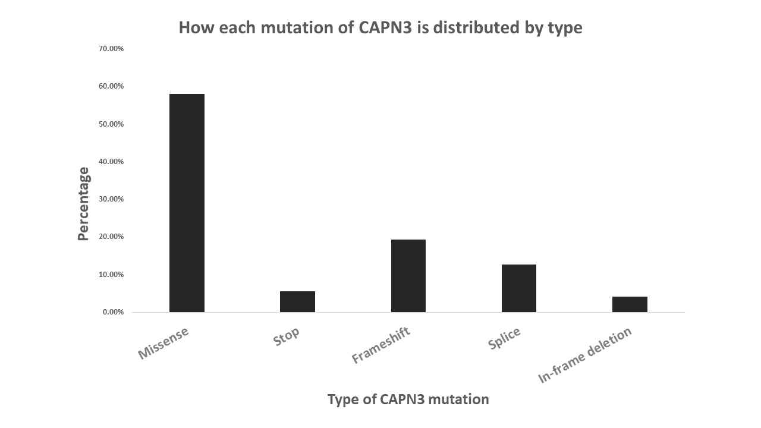
Figure 1. The possible types of mutations that could occur in CAPN3 and their distribution by percentage. These results are based on patients from many geographic areas. Out of several different mutations that could take place in CAPN3, missense mutations are the most predominant form and in-frame deletions are less frequent. Adapted from, Kramerova et al., 2007

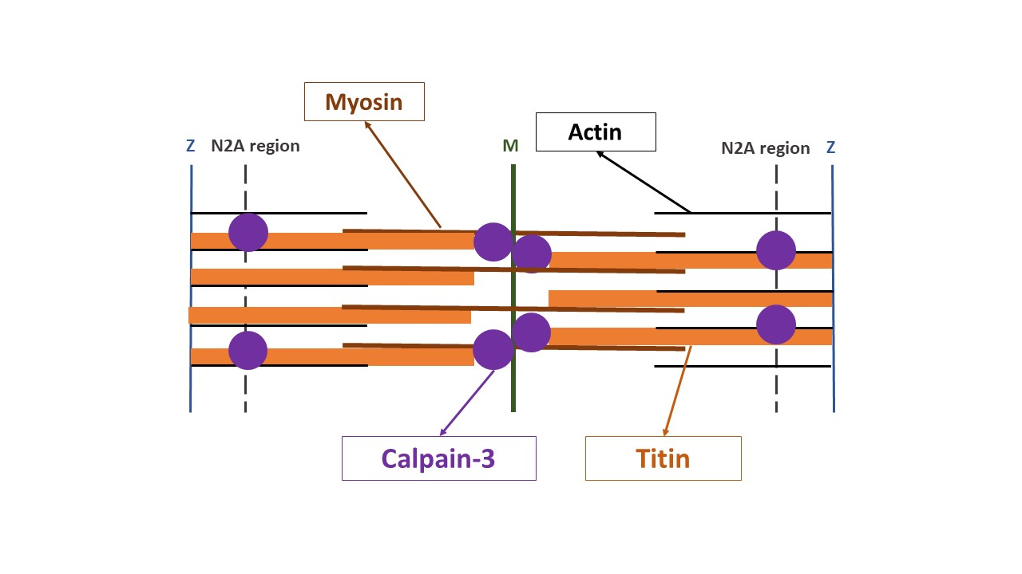
Figure 2. A schematic demonstrating how calpain-3 binds to titin and their position in the sarcomere. Calpain-3 is believed to be involved with muscle contractility as its binding allows titin to localize from the M line to N2A allowing the sarcomere to extend. Adapted from, Kramerova et al., 2007.

References
Gallardo E, Saenz A, Illa I (2011) Limb-girdle muscular dystrophy 2A. Handb Clin Neurol 101: 97-110
Kramerova I, Beckmann JS, Spencer MJ (2007) Molecular and cellular basis of calpainopathy (limb girdle muscular dystrophy type 2A). Biochimica et Biophysica Acta (BBA)-Molecular Basis of Disease 1772: 128-144
Nigro V, Aurino S, Piluso G (2011) Limb girdle muscular dystrophies: update on genetic diagnosis and therapeutic approaches. Curr Opin Neurol 24: 429-436
Rekik S, Sakka S, Ben Romdhan S, Farhat N, Baba Amer Y, Lehkim L, Authier FJ, Mhiri C (2019) Novel Missense CAPN3 Mutation Responsible for Adult-Onset Limb Girdle Muscular Dystrophy with Calves Hypertrophy. J Mol Neurosci: 1-7
Saenz A, Leturcq F, Cobo AM, Poza JJ, Ferrer X, Otaegui D, Camano P, Urtasun M, Vilchez J, Gutierrez-Rivas E (2005) LGMD2A: genotype–phenotype correlations based on a large mutational survey on the calpain 3 gene. Brain 128: 732-742
Sorimachi H, Kinbara K, Kimura S, Takahashi M, Ishiura S, Sasagawa N, Sorimachi N, Shimada H, Tagawa K, Maruyama K, et al. (1995) Muscle-specific calpain, p94, responsible for limb girdle muscular dystrophy type 2A, associates with connectin through IS2, a p94-specific sequence. J Biol Chem 270: 31158-62
Wicklund MP (2013) The muscular dystrophies. CONTINUUM: Lifelong Learning in Neurology 19: 1535-1570

