The Role of IL-18 in Abdominal Aortic Aneurysm Formation

Abstract
Abdominal aortic aneurysms are the most prevalent form of aneurysms among the population. Since surgical repair is the only available treatment option, there is a serious need for less invasive medications. However, as it is not fully understood, more research needs to be dedicated to investigating the pathogenies behind the condition. As macrophage infiltration and inflammation are believed to be involved with aneurysmal formation, this study looks at IL-18 that stimulates the recruitment of macrophages upon being activated. We infused with angiotensin II IL-18 knocked out transgenic mice and wild type mice, to induce aneurysms and performed in immunofluorescence to look at their cross sections. Findings suggest that IL-18 inhibits the formation of aneurysms although, whether it is through reducing macrophage migration to the aortic vessel walls is unclear. Further studies need to be conducted avoiding the limitations of the current study.
Key words: Aortic abdominal aneurysms, IL-18, macrophage infiltration, inflammasomes

Introduction
Abdominal aortic aneurysms (AAA) are defined as the permanent dilation of aortic vessel wall that occurs predominantly in the infrarenal region (1, 2). Although the condition is asymptomatic, rupture of the progressively dilated vessels could be fatal (1-4). AAA remains a pathological condition with surgical repair as the only available treatment option. As surgery is associated with significant complications, extended recovery periods and reduced durability, there is a serious need for pharmaceutical treatments to prevent aneurysmal growth and rupture (1-3). Recent rodent studies have proposed smoking cessation, exercise, beta blockers, statins, angiotensin pathway inhibition and doxycycline as potential medical treatments (article 1). However, further studies are required to measure the efficacy of these interventions
Although molecular mechanisms of AAA formation are not well established, known details suggest that it is closely associated with macrophage infiltration, subsequent inflammation of the vessel wall (1, 2, 5) and production and activation of various cytokines and proteases (4). Macrophages can be activated via inflammasomes which are multimeric receptor molecules that process the activation of various pro-inflammatory cytokines and regulate inflammation in chronic disease conditions (6, 7). Evidently, inhibition of NOD-like receptor family pyrin domain-containing protein 3 (NLRP3) inflammasomes by MCC950 was able to decrease hypertension and renal inflammation in vivo (7, 8). Oligomerization of NLRP3 inflammasomes stimulated by several pathogen- and danger- associated molecular signals such as lipopolysaccharides (9), reactive oxygen species, microcrystals and high concentrations of salt, leads the conversion of pro-caspase-1 into active caspase-1 (6-8). Consequently, caspase-1 proteolytically cleaves pro-interleukin (IL)-18 into active IL-18 (7-9) which then leaves the native cells and promotes inflammation in neighbouring cells by recruiting macrophages to the site (7, 8). As IL-18 is linked with several disease states including atherosclerosis and is a vital marker of cardiovascular death (5), its contribution towards AAA pathogenesis is worth investigating. Findings of a previous study suggest a higher prevalence of AAA development is associated with elevated IL-18 levels in WT mice compared to IL-18 KO mice. Moreover, a significantly attenuated macrophage infiltration in abdominal aortas of the IL-18 KO mice was depicted than in WT mice. Therefore, IL-18 could be an attractive therapeutic target for the disease and further studies should be dedicated to understanding the role of IL-18 more thoroughly in favour of developing medical treatments based on IL-18 inhibition.
In this study, we hypothesise that IL-18 promotes macrophage infiltration and vascular inflammation which in turn promotes the formation of abdominal aortic aneurysms. We further hypothesise that the inhibition of IL-18 will reduce macrophage migration under aneurysmal settings. Through this study, we aim to determine how IL-18 deficiency affects macrophage infiltration in abdominal aortic aneurysms using IL-18 KO transgenic mouse models.

Methods

Animal and Ethics approval
Male wild type (WT) and male IL-18 knocked out (IL-18 KO) mice were bred at the La Trobe Animal Research Training Facility (Bundoora, Australia). The study was approved by the La Trobe Animal Ethics Committee (AEC 16-93).

Induction of AAA
Under inhaled isoflurane anaesthesia, WT (n=8) and IL-18 KO (n=4) mice were implanted with a subcutaneous osmotic minipump containing Angiotensin II (Ang II) and were infused with Ang II over period of 28 days to induce hypertension and therefore, make them prone to developing AAA. Another ten WT mice were implanted with a subcutaneous osmotic minipump containing 0.9% saline and were infused with saline over 28 days. Following the treatment period, all 30 mice were closely examined for eight days. All mice were in individually ventilated chambers with free access to regular chow and water during that period.

Immunofluorescence staining
At the end of the in vivo treatment period, all WT and IL-18 KO mice were killed through CO₂ asphyxiation. Their abdominal aortas were freshly harvested and snap frozen in Tissue-Tek® O.C.T (Sakura Finetek, Japan) overnight at 4ºC. Cryosections of isolated aortas were cut into 5 μm sections using Leica cryostat and were placed on slides. One slide contained about 2-3 cross sections from the same mouse model. WT and IL-18 KO tissue sample were infused in acetone to fix the cells before proceeding. Upon being washed multiple times with phosphate buffer solution (PBS), BSA was added to both tissue samples to prevent unspecific binding. The primary antibody, rat anti-mouse F4/80 was added and left overnight in 4ºC. The following day, after washing with PBS multiple times the secondary antibody, Alexa Fluor 555-conjugated goat anti-rabbit IgG was added and left for two hours in room temperature before visualizing the results through microscopy.
A primary negative control group were included whereby primary antibodies were omitted and only secondary antibodies were incubated with a specimen, this is in order to ensure there is no non-specific binding of the secondary antibody.
Slides were then treated with fluorescence mounting medium (Vectorshield anti-fade mounting medium) and visualised under 20-40X magnification using Olympus BX-8 epifluorescent microscope with an Olympus DP-10 camera attached.

Determining the degree of macrophage infiltration
Image J software was used to determine the degree of macrophage infiltration. Relative fluorescence as a percentage of the total cross-sectional area of the aortic cross sections was calculated.

Statistical Analysis
Graph Pad Prism was used to analyse the acquired data. An unpaired T test was conducted to carry out a comparative analysis between test and control groups. A P value of 0.01 was considered to be statistically significant.

Results

Ang-II infusion did not develop AAA in IL-18 KO mice
As expected, there was no development in AAA in IL-18 KO mouse models upon being infused with Ang-II over a period of 28 days. Furthermore, the WT mice who were treated with Ang-II did develop AAA while the saline infused WT mice had no acquired AAA.

Macrophage infiltration is decreased in IL-18 KO mice
Consistent with the previous studies (article 6), macrophage infiltration in IL-18 KO mice were lower compared to the WT AAA mice. Although this decrease was not statistically significant (p = 0.09), there was a trending towards reduction in macrophage infiltration in IL-18 KO mice (figure 2.1). However, since IL-18 KO mice did not develop AAA even after being infused with Ang-II, it is only realistic to directly compare the degree of macrophage infiltration between only the IL-18 KO mice and the WT mice with no AAA. Such a comparison does not depict much difference in data between the two groups (figure 2.3). On the other hand, if the WT mice with no AAA are unaccounted for, the level of macrophage infiltration in WT AAA mice is strikingly higher than that of IL-18 KO mice (figure 2.2).

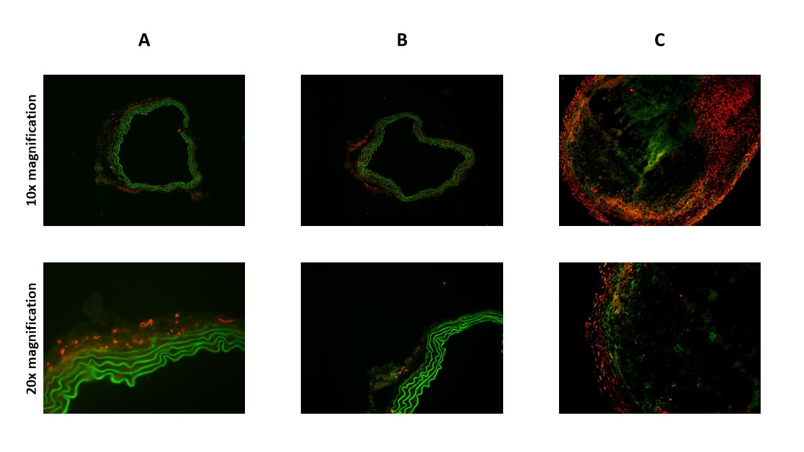
Figures
Figure 1. Representation of macrophage infiltration in blood vessel adventitia of each type of mouse models. Immunofluorescence staining of the aortic cross sections of Ang II treated (A) IL-18 KO mice and (B) WT mice versus saline treated (C) WT mice. Green = the elastin layer in vessel wall; orange = macrophage staining.

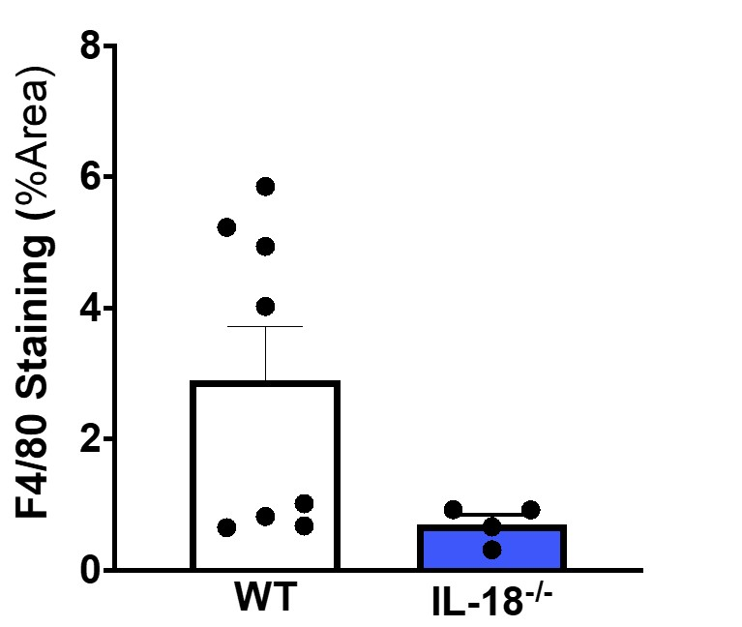
Figure 2.1 IL-18 KO mice shows a reduction in macrophage infiltration. Although the data appeals no statistical significance, upon being subcutaneously infused with Ang-II over a period of 28 days, IL-18 KO mice depicts a trend towards reducing expression of macrophages in their aortic cross sections while WT mice still have a higher degree of macrophage infiltration. The data is presented as mean ± SD (n=12). *Significance difference, p < 0.05.
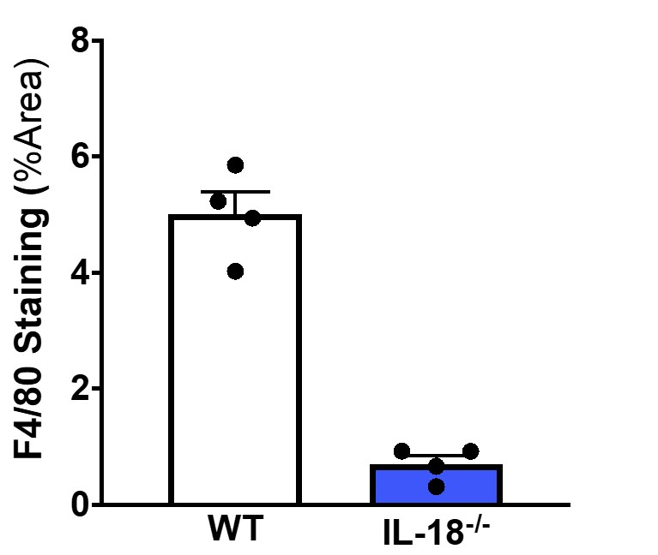
Figure 2.2 IL-18 KO mice shows a significant reduction of macrophage infiltration when compared to WT mice with AAA. When WT mice with no AAA are unaccounted for, IL-18 KO mice demonstrates a striking decrease in macrophage infiltration when compared to WT mice with AAA. However, these two test groups should not be used to make direct comparisons as the IL-18 KO mice have no AAA unlike the WT group. It can be hypothesised that IL-18 causes a spike in macrophages but through the technique used in the current study, it cannot be proven that it’s the reduction of macrophages that due to the absence of IL-18. The data is presented as mean ± SD (n=12). *Significance difference, p < 0.05.
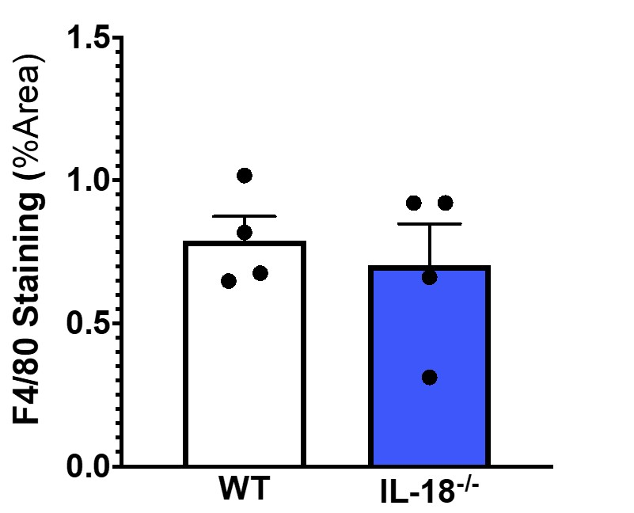
Figure 2.3 There is no definitive reduction of macrophage infiltration in IL-18 KO mice when compared to WT mice with no AAA. When WT mice with AAA are unaccounted for, there is no clear distinction between the number of macrophages that infiltrate the aortic vessel wall in IL-18 KO mice and WT mice with no developed AAA. Since both groups have no AAA, critical analysis of the data should be done focusing more on these two groups. The data is presented as mean ± SD (n=12). *Significance difference, p < 0.05.

Discussion
This study mainly demonstrated that (1) Ang-II infusion leads to no development of AAA in IL-18 KO mice where WT mice successfully develop AAA under the same conditions and (2) that there is no significant difference in macrophage infiltration between aortic cross sections of IL-KO mice and WT mice with no AAA when WT AAA mice are not accounted for.
Literature suggests that activated IL-18 administers the recruitment of macrophages and these macrophages play a role in the development of AAA through directing the inflammation in blood vessel walls (reference). Thus, the current study sought to determine whether knocking out IL-18 may reduce the degree to which the vessel wall adventitia gets infiltrated by macrophages under aneurysmal settings. Furthermore, the study was conducted under the hypothesis that if there is a reduction, it is caused due to the absence of IL-18. Results of the study do confirm that IL-18 KO mice are protected against AAA although if this is caused due to a reduction in macrophages resulted by the knocking out of IL-18 is not clear. Since IL-18 KO mice 100% did not develop any aneurysms, it is not feasible to directly compare their statistics with the WT mice who have aneurysms. As there is no noticeable decrease in macrophages in IL-18 KO mice when compared with WT mice with no AAA, it can be suggested that IL-18 may be limiting the development of AAA but does not necessarily reduce macrophage infiltration under aneurysmal settings. If IL-18 KO mice had been able to develop aneurysms and show a reduction in macrophages at the same time, it would have been realistic to compare transgenic mice with WT mice. However, previous studies demonstrate that knocking out IL-18 causes a lessening of macrophages in Ang-II infused hypertensive mouse models (elaborate - references).
Being unable to make direct comparisons can be stated as a limitation of this study. More quantitative methods such as flow cytometry must be used in further studies. Moreover, an in vitro technique like a macrophage migration assay could be more effective in future studies when addressing whether IL-18 really does recruit macrophages and if its absence causes a reduction in macrophage migration.
In conclusion, since AAA progression and rupture has higher rates of morbidity and mortality, and surgery is the only treatment available, there is a serious need for an optimal medical therapy. AAA development is associated with macrophage infiltration and inflammation and IL-18 is believed to be a centre player owing to its role in macrophage infiltration. It is hypothesised that IL-18 inhibition causes a reduction in macrophage infiltration in aortic abdominal aneurysms. However, as the current study could not justify the effect of IL-18 inhibition in abdominal aortic aneurysms, better techniques need to be used to explore the underlying research question. Further studies may aid in understanding the role of IL-18 more thoroughly in favour of developing medical treatments based on IL-18 inhibition.

References

