Me in a Minute

Graduate learning outcomes
- Discipline-specific knowledge and capabilities
- Communication
- Digital literacy
- Self-management
- Teamwork
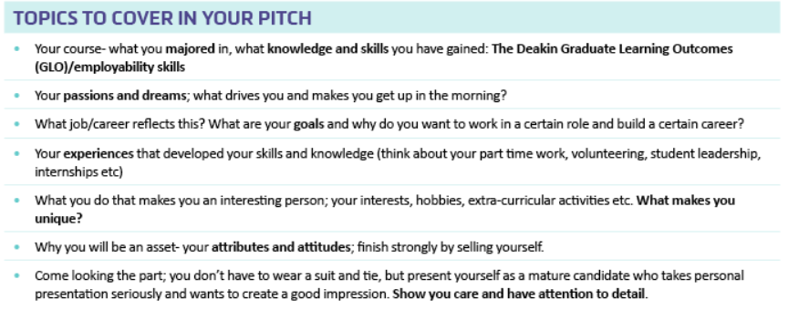
Course – Bachelor of Biomedical Science majoring in Physiology and Anatomy in La Trobe University, hoping to complete honours in Human Biosciences.
Knowledge and skills
- managed to secure an internship at La Trobe Institute for Molecular Science
  - Conducted a scientific research project with a partner under the supervision of experts in the field.
  - Experienced what it’s like to be conducting research in a real lab setting and deliver your findings in a symposium
(It is certainly different from attending a lab class that runs for six hours)
  - Developed self-management skills, resilience, communication and teamwork
- doing a capstone subject that involves conducting a scientific research project under the supervision of an expert in the field (HBS3IRP) and deliver your findings in a poster presentation session.
- Volunteered as an International student host for two semesters
  - This task involved organizing the university international student check-in and orientation weeks and welcoming and helping particularly the new international students to get used to their new environment
  - Had to report to work according to a work roster
  - Helped me develop communication skills, teamwork, problem solving skills. Having to tackle with students from various cultural backgrounds certainly instilled global citizenship skills.
- Working as a casual research assistant at RMIT University, School of Engineering
  - My tasks are to test the functionality of a mobile application and its web application designed for the smart management of infrastructure assets of several government organizations, send newsletters to our clients to keep them in the loop and update our website.
  - Working in a completely different field to my academic background has definitely been a challenge. But that has certainly broadened my horizons and helped me develop a number of qualities that would prepare me for the work life. Self-management, resilience, problem-solving skills, being a team player.
I am passionate about the medical research field and wish to pursue a career that accommodates me to discover new ways to approach unruly diseases. I am particularly interested in cardiovascular diseases and cancer as the numbers of patients are seemingly increasing.
I know I am a good candidate as I am very passionate about what I am interested in, have experience being in the research environment and enthusiastic to gain more, flexible and resilient.

